Adjacent Line Segments
# Source: AI Source: Provided by: [Data Path: Persons Table -> ID Column: 1, Name_En Column: Motasem Essam] -> From: [ChatGPT] on [7/25/2026]
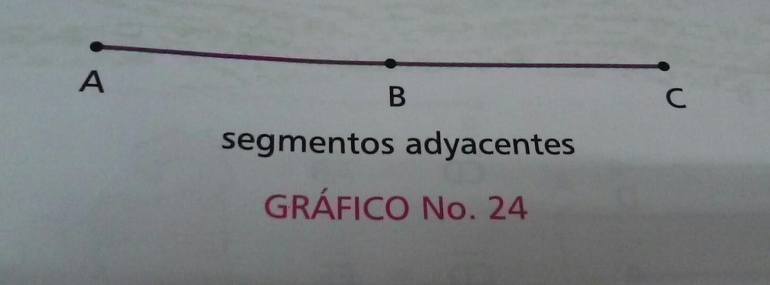
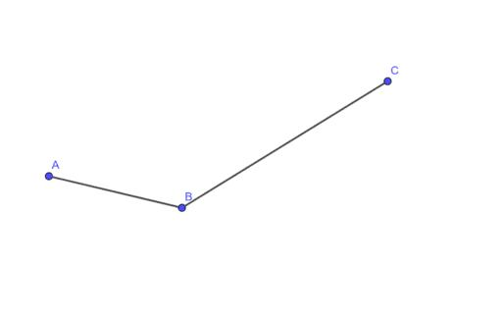
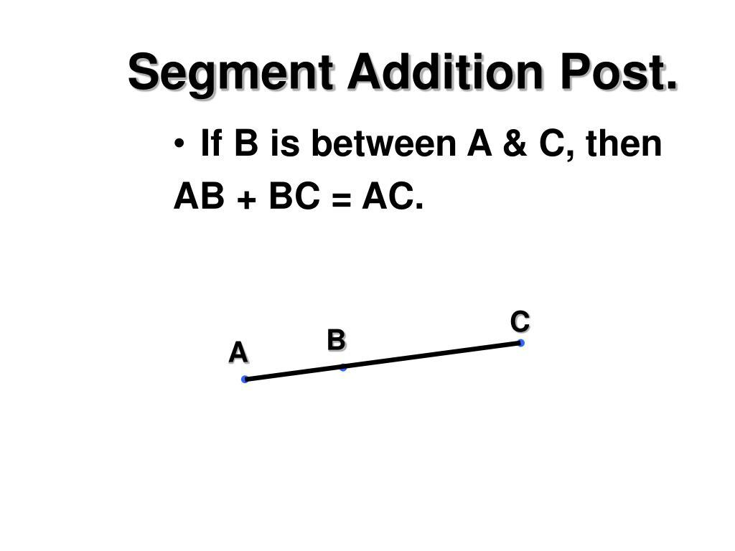

Definition
# Source: AI Source: Provided by: [Data Path: Persons Table -> ID Column: 1, Name_En Column: Motasem Essam] -> From: [ChatGPT] on [7/25/2026]
Adjacent Line Segments are two line segments that share a common endpoint and are connected directly without overlapping. They are placed next to each other and together may form a longer segment, an angle, or part of a geometric figure.
Unlike separate line segments, adjacent line segments are joined at one endpoint.

Characteristics
# Source: AI Source: Provided by: [Data Path: Persons Table -> ID Column: 1, Name_En Column: Motasem Essam] -> From: [ChatGPT] on [7/25/2026]
Adjacent line segments:
- Have one common endpoint.
- Have finite lengths.
- Do not overlap except at the shared endpoint.
- May lie on the same line or on different lines.
- Can form angles or larger geometric figures.

Illustration
# Source: AI Source: Provided by: [Data Path: Persons Table -> ID Column: 1, Name_En Column: Motasem Essam] -> From: [ChatGPT] on [7/25/2026]
Adjacent Collinear Line Segments
A ●────────●────────● C
B
- $\overset{‾}{AB}$and $\overset{‾}{BC}$are adjacent line segments.
- They share endpoint B.
- Together they form the longer segment $\overset{‾}{AC}$.

Adjacent Non-Collinear Line Segments
# Source: AI Source: Provided by: [Data Path: Persons Table -> ID Column: 1, Name_En Column: Motasem Essam] -> From: [ChatGPT] on [7/25/2026]
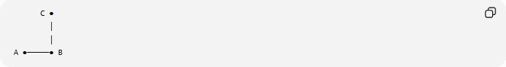
C ●
│
│
A ●─────● B
- $\overset{‾}{AB}$and $\overset{‾}{BC}$are adjacent.
- They share endpoint B.
- Together they form an angle.

Mathematical Representation
# Source: AI Source: Provided by: [Data Path: Persons Table -> ID Column: 1, Name_En Column: Motasem Essam] -> From: [ChatGPT] on [7/25/2026]
If two line segments
$$\overset{‾}{AB}$$
and
$$\overset{‾}{BC}$$
share endpoint
$$B$$
then they are adjacent line segments.

Collinear Case
# Source: AI Source: Provided by: [Data Path: Persons Table -> ID Column: 1, Name_En Column: Motasem Essam] -> From: [ChatGPT] on [7/25/2026]
If A, B, and C are collinear:
$$AC=AB+BC$$

Examples
# Source: AI Source: Provided by: [Data Path: Persons Table -> ID Column: 1, Name_En Column: Motasem Essam] -> From: [ChatGPT] on [7/25/2026]
Examples of adjacent line segments include:
- Consecutive sides of a polygon.
- Two connected pieces of a ruler.
- Adjacent edges of a rectangle.
- Connected beams in a framework.
- Segments joined at a corner.

Properties
# Source: AI Source: Provided by: [Data Path: Persons Table -> ID Column: 1, Name_En Column: Motasem Essam] -> From: [ChatGPT] on [7/25/2026]
Adjacent line segments:
- Share exactly one endpoint.
- Have no overlapping interiors.
- May be collinear or non-collinear.
- Can be combined into longer geometric structures.
- Often serve as the sides of an angle or polygon.

Applications
# Source: AI Source: Provided by: [Data Path: Persons Table -> ID Column: 1, Name_En Column: Motasem Essam] -> From: [ChatGPT] on [7/25/2026]
Adjacent line segments are used in:
- Plane Geometry
- Coordinate Geometry
- Engineering
- Architecture
- Construction
- CAD (Computer-Aided Design)
- Technical Drawing
- Surveying
- Robotics
- Computer Graphics

Advantages
# Source: AI Source: Provided by: [Data Path: Persons Table -> ID Column: 1, Name_En Column: Motasem Essam] -> From: [ChatGPT] on [7/25/2026]
Studying adjacent line segments helps to:
- Construct polygons.
- Analyze composite lengths.
- Build geometric figures.
- Model connected structures.
- Solve geometric proofs.

Limitations
# Source: AI Source: Provided by: [Data Path: Persons Table -> ID Column: 1, Name_En Column: Motasem Essam] -> From: [ChatGPT] on [7/25/2026]
Adjacent line segments:
- Must share a common endpoint.
- Are not considered adjacent if they only intersect without sharing an endpoint.
- Do not overlap except at the shared endpoint.

Comparison with Related Objects
# Source: AI Source: Provided by: [Data Path: Persons Table -> ID Column: 1, Name_En Column: Motasem Essam] -> From: [ChatGPT] on [7/25/2026]
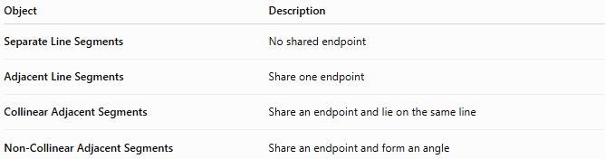
Object | Description
Separate Line Segments | No shared endpoint
Adjacent Line Segments | Share one endpoint
Collinear Adjacent Segments | Share an endpoint and lie on the same line
Non-Collinear Adjacent Segments | Share an endpoint and form an angle

Key Points
# Source: AI Source: Provided by: [Data Path: Persons Table -> ID Column: 1, Name_En Column: Motasem Essam] -> From: [ChatGPT] on [7/25/2026]
- Adjacent Line Segments share one common endpoint.
- They do not overlap except at the shared endpoint.
- They may be collinear or non-collinear.
- Collinear adjacent segments satisfy:
$$AC=AB+BC$$
- Adjacent line segments are fundamental in geometry, engineering, architecture, CAD, surveying, and technical drawing.

Conclusion
# Source: AI Source: Provided by: [Data Path: Persons Table -> ID Column: 1, Name_En Column: Motasem Essam] -> From: [ChatGPT] on [7/25/2026]
Adjacent Line Segments are finite line segments that share a single common endpoint while remaining distinct along their lengths. They may lie on the same straight line to form a longer segment or meet at an angle to become the sides of a geometric figure. Adjacent line segments are fundamental in plane geometry, coordinate geometry, engineering, architecture, construction, surveying, CAD, technical drawing, robotics, and computer graphics, where they are used to build polygons, represent connected structural elements, and analyze composite lengths and geometric relationships.

